A Real Time Project Report on

" STUDENT INFORMATION SYSTEM"

*Submitted to the*

GURU NANAK INSTITUTIONS TECHNICAL CAMPUS (AUTONOMOUS)

*In partial fulfillment of the requirement for the award of the degree of*

BACHELOR OF TECHNOLOGY

IN

COMPUTER SCIENCE & ENGINEERING

BY

Vembadi Keerthana (22WJ1A05Z0)

Under the Esteemed Guidance Of

Mr. Devdas Saraswat,

Associate Professor of CSE, GNITC



Department Of Computer Science Engineering

GURU NANAK INSTITUTIONS TECHNICAL CAMPUS (AUTONOMOUS)

School of Engineering and Technology, Ibrahimpatnam, R.R District 501506, 2023-2024

### 

### 

### Department of Computer Science & Engineering

**CERTIFICATE**

This is to certify that this Real Time project entitled **"STUDENT INFORMATION SYSTEM "** being submitted by **Vembadi keerthana (22WJ1A05Z0),** in partial fulfilment for the award of the Degree of **Bachelor of Technology** in **Computer Science** & **Engineering** of the **GuruNanak Institution Technical Campus, Hyderabad** during the academic year 2023-2024, is a record of bonafide work carried out under our guidance and supervision at **Guru Nanak Institutions Technical Campus (Autonomous).**

**Mr. Devdas Saraswat Mr. V. Devasekhar Dr. Geeta Tripathi**

RTP PROJECT COORDINATORACADEMIC COORDINATOR HOD CSE

**PROJECT** **COMPLETION** **CERTIFICATE**

This is to certify that the following students of Second year B. Tech, Department Of **Computer Science and Engineering** - Guru Nanak Institutions Technical Campus (GNITC) have completed their training and project at GNITC successfully.

## STUDENT NAME**:**

**Vembadi keerthana**

**ROLL NO** **:22WJ1A05Z0**

The project titled **"STUDENT INFORMATION SYSTEM "** in **june 2024.** The project has been completed in all aspects.

**SIGNATURE**

**ACKNOWLEDGEMENT**

I wish to express my sincere thanks to **Dr. Rishi Sayal, Professor & Associative Director, GNITC** for providing me with the conductive environment for carrying through my academic schedules and project with ease.

I have been truly blessed to have a wonderful adviser **Dr. Geeta Tripathi professor & HOD of CSE, GNITC** for guiding me to explore the ramification of my work and I express my sincere gratitudetowards him for leading me throughout the completion of the project.

I would like to say my sincere thanks to **Mr. Devdas Saraswat, Associate Professor, Department of CSE, RTP Project Coordinator,** for providing seamless support and right suggestions are given in the completion of the project.

I specially thank my internal guide **Mr. V. Devasekhar, Associate Professor & Academic co ordinator of CSE, GNITC** for his suggestions and constant guidance in every stage of the project.

Finally, I would like to thank my family members for their moral support and encouragement to achieve goals.

**Vembadi keerthana**

**(22WJ1A05Z0)**

**ABSTRACT**

The Student Information System (SIS) is a crucial tool for educational institutions to manage student data efficiently. This presentation outlines the development of a SIS using Java programming. We'll delve into its architecture, functionalities, advantages, and potential limitations

A Student Information System (SIS) is a crucial tool for educational institutions to manage student data comprehensively and efficiently. It serves as a central repository for student-related information, encompassing academic records, personal details, enrollment status, and administrative functions.

The primary objective of a SIS is to streamline administrative tasks, enhance communication between stakeholders, and provide valuable insights through data analytics. Key features often include:

1. **Student Records Management:** Capturing and storing student demographics, academic transcripts, attendance records, and disciplinary history.
2. **Enrollment and Registration:** Facilitating the enrollment process, course registration, and managing class schedules.
3. **Grading and Transcripts:** Recording grades, calculating GPA, and generating official transcripts.
4. **Communication:** Enabling communication channels between students, parents, faculty, and administrators.
5. **Administrative Tools:** Supporting administrative tasks such as financial aid management, fee payments, and reporting.

The benefits of implementing a SIS include improved data accuracy, enhanced efficiency in administrative processes, better decision-making through data-driven insights, and increased transparency for all stakeholders. Modern SIS solutions often integrate with other educational systems and offer mobile-friendly interfaces for accessibility.

## TABLE OF CONTENT



|  |  |  |
| --- | --- | --- |
| **CHAPTER NO.** | **TITLE** | **PAGE NO** |
|  |  |  |
| 1. | **CHAPTER 1: INTRODUCTION**   * 1. Scope   2. Objective | 1-2  2  2 |
| 2. | **CHAPTER 2: ANALYSIS**   * 1. Existing System   2. Problem Statement   3. Proposed System   4. Feasibility Study      1. Economical Feasibility      2. Technical Feasibility      3. Operational Feasibility | 3-4  3  3  3  4  4  4 |
| 3. | **CHAPTER 3: DESIGN ENGINEERING**  3.1System Architecture   * 1. Module Diagram   2. Activity Diagram   3. Class Diagram   4. Use Case Diagram | 5-8  5-6  6  7  7  8 |
| 4. | **CHAPTER 4: IMPLEMENTATION**   * 1. Purpose   4.2 Maintenance  4.3 Source Code | 9-13  9  9  10-13 |

|  |  |  |
| --- | --- | --- |
| 5. | **CHAPTER 5: SOFTWARE TESTING5.1** Introduction  5.1Testing Methodologies   * + 1. Unit Testing     2. System Testing     3. Performance Testing   1. Test Cases | 14-16  14  14  15-16 |
| 6 | **CHAPTER 6: POST IMPLEMENTATION**  6.1Purpose  6.2 Maintenance  6.3 RESULT | 17-21  17  18-21 |
| 7. | **CHAPTER 7: CONCLUSION** &  **FUTURE ENHANCEMENT**   * 1. Future Enhancement   Conclusion | 22 |

**CHAPTER-1**

**INTRODUCTION**



* 1. **GENERAL**

Designing a Student Information System (SIS) involves several key components and considerations to ensure it meets the needs of students, faculty, and administrative staff effectively. Here’s a general outline to guide you through the project. Building a Student Information System requires a structured approach from requirements gathering to deployment and maintenance. Collaborate closely with stakeholders throughout the process to ensure the system meets their expectations and enhances the educational experience effectively.

**1.1.1 Scope**

When developing a Student Information System (SIS) using Java, the scope remains largely similar to any other SIS, focusing on functionalities tailored to manage student, faculty, and administrative operations within an educational institution. Here's a detailed scope outline for a Java-based SIS. Developing a Student Information System using Java involves leveraging its robust ecosystem of frameworks and tools to build a secure, scalable, and efficient system that meets the needs of educational institutions. By carefully defining and adhering to the scope outlined above, you can ensure the successful development and deployment of an effective SIS tailored to your institution's requirements.

**1.1.2 Advantages**

1. Improved Efficiency:

Advantage: Automates administrative tasks such as enrollment, registration, grading, and attendance tracking, reducing paperwork and saving time.

2. Enhanced Data Management:

Advantage: Centralizes student data, making it easier to access and update. This improves data accuracy and reduces errors in record-keeping.

3. Better Communication:

Advantage: Facilitates communication among students, parents, teachers, and administrators through portals, messaging systems, and notifications.

4. Data Analysis and Reporting:

Advantage: Provides tools for generating reports and analytics that help educators and administrators make informed decisions about curriculum, student performance, and resource allocation.

5. Supports Decision-Making:

Advantage: Enables data-driven decision-making by providing insights into enrollment trends, academic outcomes, and institutional effectiveness.

6. Enhanced Parental Involvement:

Advantage: Allows parents to track their child’s academic progress, attendance, and communication with teachers, fostering greater parental involvement in education.

7. Scalability:

Advantage: Can scale to accommodate growing student populations and evolving institutional needs without significant disruption.

**1.1.3 Disadvantages**

1. Cost:

Disadvantage: Initial setup and ongoing maintenance costs can be substantial, especially for smaller institutions with limited budgets.

2. Complexity:

Disadvantage: Implementing and customizing an SIS to fit institutional needs can be complex and time-consuming.

3. User Training:

Disadvantage: Requires training for administrators, teachers, and staff to effectively use the system, which can be resource-intensive.

4. Data Security Concerns:

Disadvantage: Centralized storage of sensitive student data raises concerns about data security breaches and compliance with data protection regulations (e.g., GDPR, FERPA).

5. Integration Challenges:

Disadvantage: Integrating the SIS with existing systems (e.g., LMS, finance systems) can pose technical challenges and compatibility issues.

6. Dependence on Technology:

Disadvantage: Reliance on technology means that system downtime or technical issues can disrupt operations and access to critical student information.

7. Resistance to Change:

Disadvantage: Some stakeholders, such as faculty or staff, may resist adopting new technologies or changes in administrative processes, impacting implementation success.

**1.2 Objective**

**Efficient Student Management**

* **Objective:** Enable seamless registration, course enrollment, and profile management for students.
* **Details:** Develop functionalities for student registration, course selection, viewing grades, and managing personal information efficiently.

**2. Comprehensive Academic Management**

* **Objective:** Facilitate effective management of courses, grading, and academic records.
* **Details:** Implement features for course creation, scheduling, grading systems, transcript generation, and academic progress tracking.

**3. Faculty Management and Collaboration**

* **Objective:** Provide tools for faculty to manage courses, communicate with students, and evaluate academic performance.
* **Details:** Develop functionalities for faculty profiles, course management, assignment grading, and communication tools within the system.

**4. Administrative Operations**

* **Objective:** Streamline administrative tasks related to admissions, financial aid, and student records.
* **Details:** Implement features for managing admissions processes, financial aid distribution, fee management, and generating institutional reports.

**5. User Experience and Accessibility**

* **Objective:** Ensure a user-friendly interface and accessibility for all users.

**CHAPTER -2**

**ANALYSIS**



During this phase, all the relevant information is collected from the customer to develop a product as per their expectation. Any ambiguities must be resolved in this phase only.

**2.1 Existing System**

The existing systems for Student Information Systems (SIS) vary widely across educational institutions, often reflecting a mix of manual processes and digital solutions. Traditionally, many institutions rely on fragmented approaches, where student records, course management, and administrative tasks are handled through disparate systems, spreadsheets, or even paper-based methods. This fragmented approach can lead to inefficiencies and inaccuracies in data management, as well as challenges in accessing timely and comprehensive information for students, faculty, and administrators. In some cases, institutions may use legacy software applications that lack integration capabilities or are outdated in terms of technology and user interface design. These systems often require extensive manual data entry and lack real-time updates, impacting the ability to provide timely academic information and support services to stakeholders.

**2.2 Problem Statement**

The current state of student information management at many educational institutions presents several critical challenges that highlight the need for a comprehensive solution. Existing systems often suffer from outdated technology, fragmented data management practices, and inadequate user interfaces. These factors contribute to inefficiencies in student enrollment, course registration, academic record keeping, and administrative tasks. Manual processes and reliance on disparate systems lead to errors, delays, and inconsistencies in data, impacting the institution's ability to provide timely and accurate information to students, faculty, and administrators. Moreover, security concerns arise due to insufficient data protection measures and compliance risks with regulatory standards such as FERPA and GDPR. The lack of integration among various institutional systems further complicates data accessibility and hinders collaboration across departments.

**2.3 Proposed System**

The proposed Student Information System (SIS) aims to address the shortcomings of existing systems by introducing a modern, integrated platform built on Java technologies. This new system will revolutionize how educational institutions manage student information, offering robust features and functionalities to streamline operations and enhance user experience.At its core, the SIS will automate and optimize key processes such as student registration, course management, and academic record keeping. It will provide a centralized database with secure access controls, ensuring data integrity and confidentiality in compliance with regulatory requirements like FERPA and GDPR. The system will feature intuitive interfaces tailored for different user roles—students, faculty, and administrators—promoting ease of use and accessibility.

**2.4 Feasibility Study**

**2.4.1 Economical Feasibility**

The economical feasibility of implementing a Student Information System (SIS) involves evaluating the costs and benefits associated with developing, deploying, and maintaining the system compared to the potential savings and improvements it can bring to the institution.Initially, there are upfront costs related to the development of the SIS, including software development, hardware infrastructure (if not using cloud solutions), licensing fees for necessary software components, and possibly training for staff on the new system. These costs are significant but are typically justified by the potential long-term savings and efficiencies gained from automation and improved data management.

**2.4.2 Technical Feasibility**

A Student Information System (SIS) is pivotal in modern educational institutions for managing student data effectively. From enrollment to graduation, an SIS streamlines administrative tasks such as registration, attendance tracking, grade recording, and more.Technically, an SIS must be robust to handle large volumes of data securely, ensuring sensitive information like grades and personal details are protected. It should integrate seamlessly with other systems like Learning Management Systems (LMS) and financial aid platforms. Scalability is crucial, allowing the system to grow with the institution and accommodate increasing numbers of students and courses. Usability is equally important, with intuitive interfaces for administrators, teachers, and students, supported by responsive design for mobile access.

.

**2.4.3 Operational Feasibility**

Operational feasibility is crucial when implementing a Student Information System (SIS) within an educational institution. It assesses the system's practicality in terms of day-to-day operations and the ease with which it can be integrated into existing workflows.

Firstly, the SIS should align with the institution's goals and operational requirements. This involves understanding the specific needs of administrators, teachers, and students, and ensuring that the system supports these needs efficiently. For example, administrators require functionalities for managing admissions, enrollment, and financial aid seamlessly, while teachers need tools for attendance tracking, grade management, and communication with students.

**CHAPTER-3**

**DESIGN**



Designing a Student Information System (SIS) involves several key considerations to ensure it meets the needs of students, faculty, and administrators efficiently. Here's a structured approach to designing a robust SIS

**Continuous Improvement:** Gather feedback from users and stakeholders to identify areas for improvement and iterate on the system

**3.1 System Architecture**

The system architecture of a Student Information System (SIS) is crucial for managing the complexities of educational data efficiently. At its core, an SIS typically consists of several interconnected components. The frontend encompasses user interfaces tailored for students, faculty, and administrators, providing functionalities such as course registration, grade viewing, and communication tools. These interfaces rely on a robust backend that handles business logic, data processing, and integration with external systems like learning management systems and financial databases. A centralized database stores student records, course information, and administrative data, ensuring data integrity and accessibility. Security measures include authentication mechanisms, role-based access controls, and encryption protocols to safeguard sensitive information. Scalability is achieved through modular design, allowing the system to accommodate growth and technological advancements while maintaining performance. Monitoring and logging tools track system performance and user interactions, supporting maintenance and continuous improvement efforts. Together, these components form a cohesive architecture that supports the diverse needs of educational institutions, enhancing administrative efficiency and student experience.

**3.2 Module Diagram**

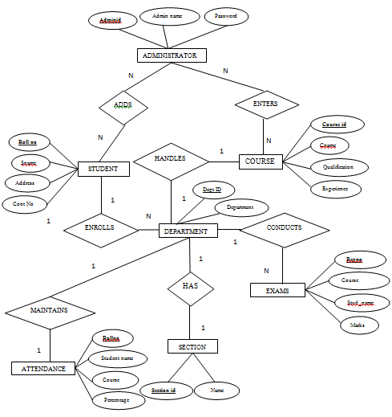

**3.3 Activity Diagram**

An activity diagram for a Student Information System (SIS) visually represents the flow of activities and processes within the system, focusing on interactions among users and system functionalities. At its core, the diagram starts with the initial activity of user authentication, where students, faculty, and administrators log into the system using their credentials. Upon successful login, users are directed to their respective dashboards or interfaces tailored to their roles. For students, activities might include viewing course offerings, registering for classes, checking grades, and accessing academic records. Faculty members can input grades, manage course materials, and communicate with students. Administrators oversee system configurations, manage user permissions, and generate reports

**3.4 Class Diagram**

A class diagram for a Student Information System (SIS) represents the static structure of the system, focusing on the classes, their attributes, methods, and relationships. Here’s a structured overview of the key classes and their relationships typically found in an SIS. This is a superclass for different types of users in the system, such as Student, Faculty, and Administrator. Each subclass inherits common attributes like username, password, and contact information, but may have additional attributes specific to their role, such as student ID for students or department for faculty.Contains attributes specific to students, such as student ID, name, date of birth, and current year of study. It may also include methods for registering courses, viewing grades, and updating personal information.

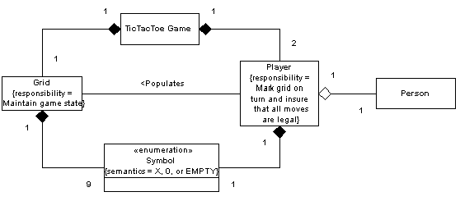

* 1. **Use Case Diagram**

A use case diagram for a Student Information System (SIS) illustrates the interactions between users (actors) and the system itself, focusing on the various functionalities and roles within the system. Here’s an overview of the key actors and their interactions typically found in an SIS

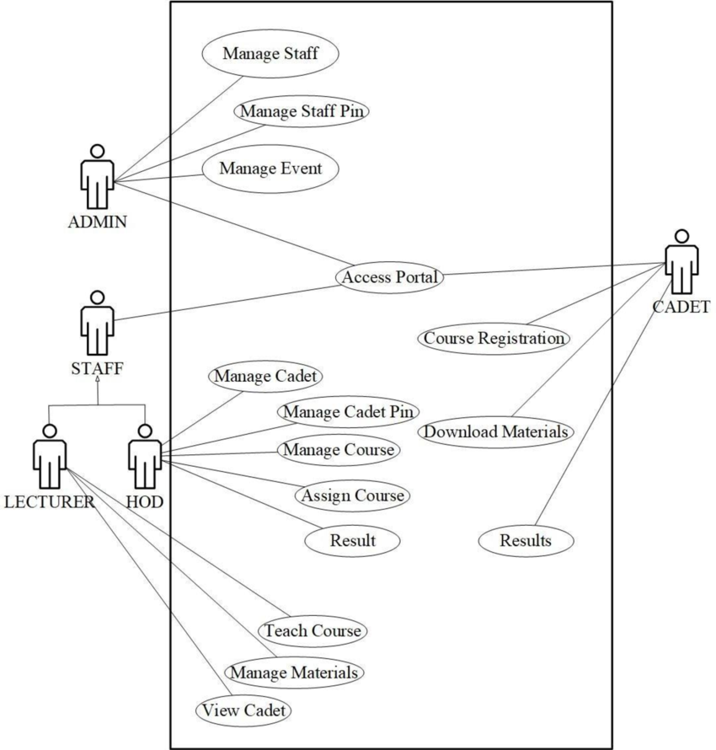

**CHAPTER -4**

**IMPLEMENTATION & CODING**

Implementation/Coding starts once the developer gets the Design document. The Software design is translated into source code. All the components of the software are implemented in this phase.

**4.1 Purpose**

The purpose of a Student Information System (SIS) is to effectively manage and organize student-related data within an educational institution. This comprehensive system serves multiple critical functions that enhance administrative efficiency, improve academic management, and enrich the overall educational experience. Student Information System serves as a vital infrastructure for educational institutions, leveraging technology to streamline administrative processes, enhance communication and collaboration, support academic excellence, and promote institutional effectiveness and student success. Its purpose extends beyond mere data management to encompass strategic insights, operational efficiencies, and holistic support for the educational community.Top of FormBottom of Form

**4.2 Maintenance**

Maintenance of a Student Information System (SIS) is crucial to ensure its continuous functionality, security, and relevance in supporting educational operations. Maintenance activities for an SIS typically include.

**Software Updates**: Implementing updates to the SIS software, including bug fixes, security patches, and feature enhancements provided by the software vendor or developer.

**Database Updates**: Managing database schema changes, optimizing queries, and ensuring data integrity through regular maintenance tasks.

* 1. **Source Code**

import java.util.*;

class Student {

private String name;

private int age;

private String id;

private String department;

public Student(String name, int age, String id, String department) {

this.name = name;

this.age = age;

this.id = id;

this.department = department;

}

public String getName() {

return name;

}

public int getAge() {

return age;

}

public String getId() {

return id;

}

public String getDepartment() {

return department;

}

public void displayInfo() {

System.out.println("Name: " + name);

System.out.println("Age: " + age);

System.out.println("ID: " + id);

System.out.println("Department: " + department);

}

}

public class StudentInformationSystem {

public static void main(String[] args) {

Scanner scanner = new Scanner(System.in);

List<Student> students = new ArrayList<>();

while (true) {

System.out.println("\n1. Add Student");

System.out.println("2. Display All Students");

System.out.println("3. Exit");

System.out.print("Enter your choice: ");

int choice = scanner.nextInt();

switch (choice) {

case 1:

System.out.print("Enter student name: ");

String name = scanner.next();

System.out.print("Enter student age: ");

int age = scanner.nextInt();

System.out.print("Enter student ID: ");

String id = scanner.next();

System.out.print("Enter student department: ");

String department = scanner.next();

Student student = new Student(name, age, id, department);

students.add(student);

System.out.println("Student added successfully!");

break;

case 2:

if (students.isEmpty()) {

System.out.println("No students added yet!");

} else {

System.out.println("\n--- Student Information ---");

for (Student s : students) {

s.displayInfo();

System.out.println("--------------------------");

}

}

break;

case 3:

System.out.println("Exiting program...");

System.exit(0);

break;

default:

System.out.println("Invalid choice! Please enter a valid option.");

}

}

}

}

**CHAPTER-5**

**TESTING**



Testing starts once the coding is complete and the modules are released for testing. In this phase, the developed software is tested thoroughly and any defects found are assigned to developers to get them fixed.

Retesting, regression testing is done until the point at which the software is as per the customer’s expectation.

**5.1 Testing Methodologies**

Testing methodologies for a Student Information System (SIS) are critical to ensure its functionality, reliability, security, and performance meet the needs of users and regulatory requirements. Here are some key testing methodologies commonly applied to SIS. By implementing unit testing in Java for a Student Information System, developers can ensure that each component operates correctly and contributes to a reliable and efficient SIS that meets the needs of educational institutions and users.

**5.1.1 Unit Testing**

Unit testing in the context of a Student Information System (SIS) developed using Java involves testing individual components, classes, and methods to ensure they function correctly according to their specifications. Here’s how unit testing can be applied effectively in Java-based development for an SIS:.

* + 1. **Integration Testing**

Testing the integration of different modules or systems within the SIS to ensure they work together seamlessly. It verifies data flow between components, APIs, and external systems like learning management systems.

* + 1. **System Testing**:**End-to-End Testing**:

Testing the entire SIS system from start to finish to simulate real-world scenarios. It validates user workflows such as student registration, course enrollment, grade submission, and report generation.

**User Acceptance Testing (UAT)**: Involving end-users (students, faculty, administrators) to test the SIS functionality in a controlled environment. It ensures the system meets user requirements and operates as expected in real-world usage scenarios.

**5.1.4 Performance Testing:**

**Load Testing**: Testing the SIS under expected load conditions to evaluate its performance and scalability. It assesses response times, throughput, and resource utilization to identify bottlenecks and optimize system performance.

**Stress Testing**: Testing the SIS beyond its normal operational capacity to determine its breaking point and behavior under extreme load conditions. It helps identify performance degradation and potential failure points.

**5.1.5 Security Testing:**

**Penetration Testing**: Simulating cyber-attacks to identify vulnerabilities in the SIS infrastructure, applications, and data security measures. It helps strengthen defenses against potential threats and ensure compliance with data protection regulations.

**Security Audits**: Reviewing and assessing the SIS security controls, access controls, encryption protocols, and authentication mechanisms to mitigate security risks and protect sensitive student information.

• **Regression Testing**:

**Regression Testing**: Testing previously validated functionalities after changes or updates to ensure existing features still work correctly. It helps prevent unintended side effects and maintains system stability and reliability.

• **Usability Testing**:

**Usability Testing**: Evaluating the SIS interface and user experience to ensure it is intuitive, accessible, and meets user needs. It involves gathering feedback from users to improve navigation, accessibility, and overall satisfaction with the system.

**5.1.6 Compatibility Testing:**

* **Compatibility Testing**: Testing the SIS across different devices, operating systems, browsers, and network environments to ensure consistent performance and functionality. It verifies compatibility with various hardware and software configurations used by stakeholders.

**5.2 Test Cases**

**Test Case: Add Student**

**Test Case ID:** SIS_TC_AddStudent_001  
**Description:** Test adding a new student to the system  
**Preconditions:**

1. The system is running without errors.
2. The user has appropriate permissions to add a student.

**Test Steps:**

1. Open the student registration form.
2. Enter valid student information:
   * Name: teja
   * Date of Birth: 2000-01-01
   * Email: johndoe@example.com
   * Address: 123 Main St, Anytown, india
3. Click on the "Save" or "Submit" button.
4. Navigate to the student list or search for the newly added student

**CHAPTER-6**

**POST IMPLEMENTATION**



After completing your project cycle, you should carry out a post-implementation review (PIR). The essence of a PIR is to discover if you met project objectives and to identify any existing flaws in the project. Project management continues until you complete the PIR process.

**6.1 Purpose**

In a Student Information System (SIS), the primary purpose is to efficiently manage and organize essential information related to students, courses, and educational institutions. The system serves several key purpose. A well-implemented SIS enhances the efficiency of educational institutions, improves communication between stakeholders, and supports data-driven decision making to foster academic excellence and student success. It serves as a central hub for managing student information throughout their educational journey.

**6.2 Maintenance**

Maintaining a Student Information System (SIS) is crucial to ensure its continued functionality, reliability, and relevance as educational institutions evolve. Here are key aspects involved in maintaining an SIS effectively. By addressing these areas, educational institutions can effectively maintain their Student Information Systems, ensuring they continue to support efficient operations, data security, and educational excellence over time. Regular evaluation and adaptation to changing needs are key to successful SIS maintenance.

**RESULTS ANALYSIS**

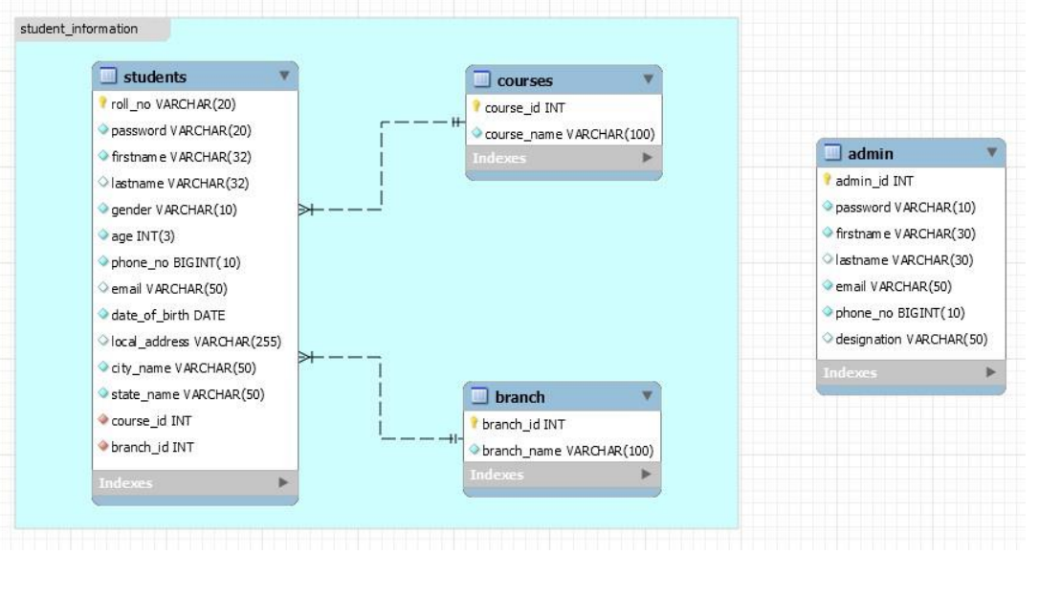

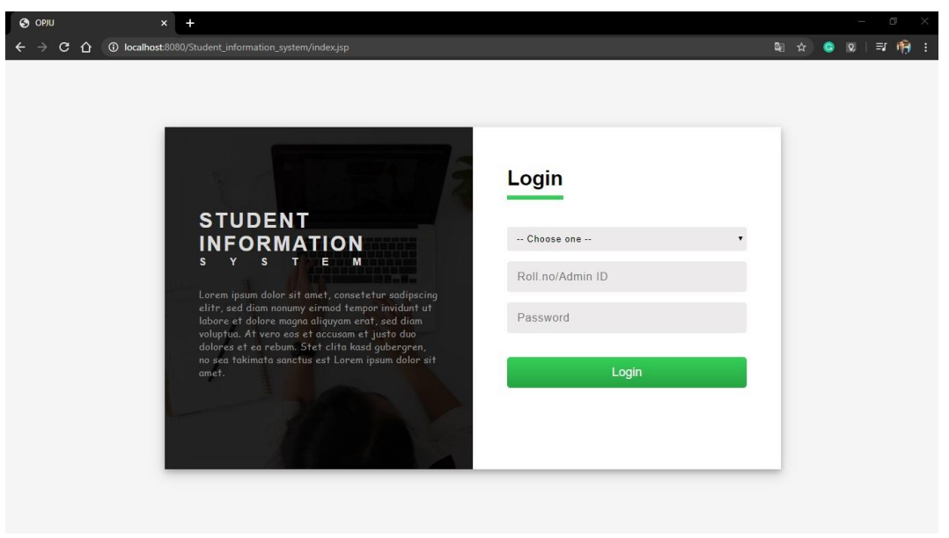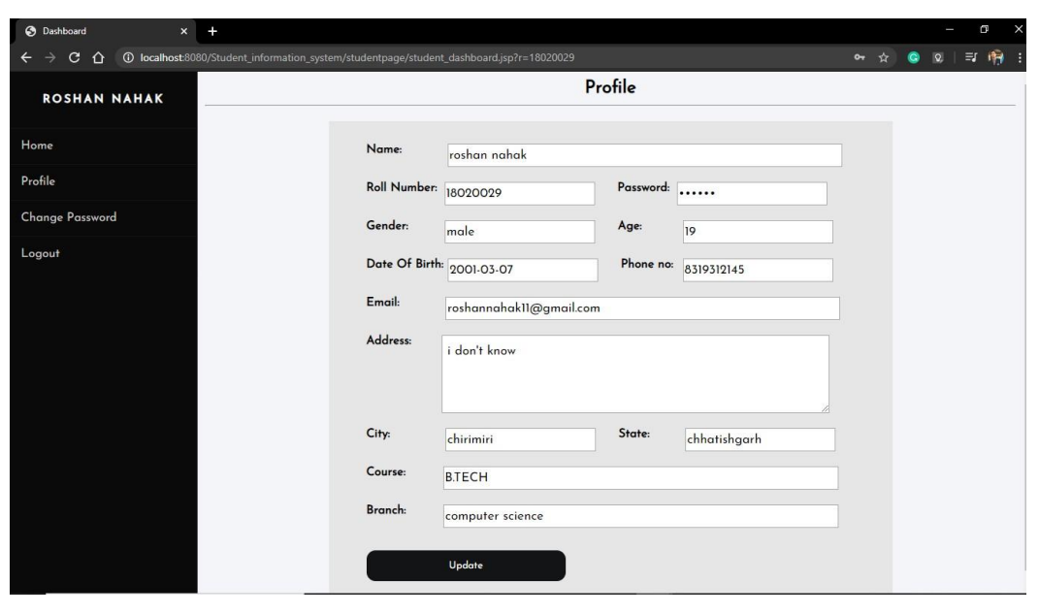

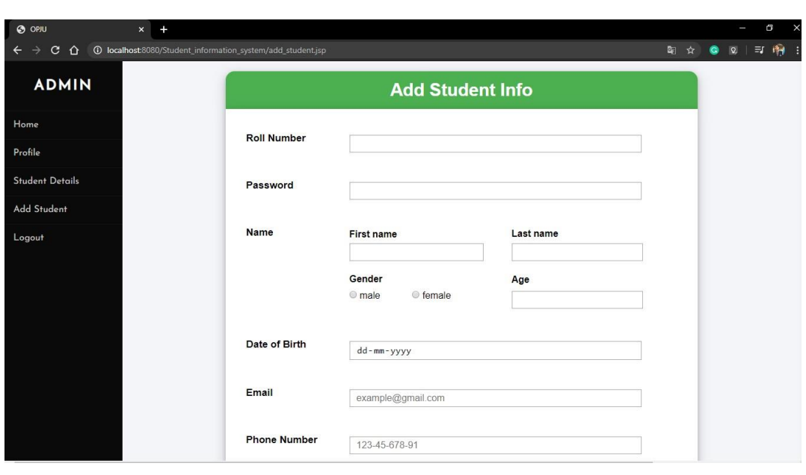



**CHAPTER-8**

**CONCLUSION**

**Future Enhancement**

Enhancing a Student Information System (SIS) involves improving functionalities, usability, and capabilities to meet evolving educational needs and technological advancements. Here are several potential future enhancements for an SIS. Implementing these future enhancements requires careful planning, stakeholder engagement, and a phased approach to deployment to minimize disruption and maximize the benefits to the educational institution and its community.

**Conclusion**

The SIS automates and centralizes student management processes, reducing administrative workload and enhancing efficiency in tasks such as registration, grading, and attendance tracking.By maintaining a centralized database, the SIS ensures data integrity and provides real-time access to accurate student information for educators, administrators, and students themselves.Features like messaging systems and integrated communication tools facilitate seamless interaction between students, teachers, and administrators, fostering a collaborative learning environment.Robust reporting and analytics capabilities enable data-driven decision making, helping educational institutions monitor student performance trends, identify areas for improvement, and allocate resources effectively.The SIS adheres to data protection regulations and implements security measures such as role-based access control and encryption to safeguard sensitive student information.

**Considerations for Future Development:**

Continuously improve the user interface and experience through modern design principles, responsiveness, and personalized customization options to cater to diverse user needs. Strengthen integration capabilities with other educational systems (e.g., Learning Management Systems, library management) to enhance data exchange and workflow efficiency. Explore the integration of AI, machine learning, and block chain for advanced functionalities such as predictive analytics, personalized learning paths, and secure credential management. Ensure accessibility features are robustly implemented to support students with disabilities and provide multilingual support to cater to diverse student populations. Adopt agile methodologies for iterative development, prioritize user feedback, and conduct regular testing and updates to address evolving educational needs and technological advancements.